Spianato e muito romântico: um acorde diminuto no Op. 22 de Chopin

Referências
ABRAHAM, Gerald. Chopin’s musical style. Londres: Oxford University Press. 1939
ALDWELL, Edward, SCHACHTER, Carl e CADWALLADER, Allen, Harmony and
Voice Leading. Cengage Learning, 2019.
BIAMONTE, Nicole. Introduction to common-tone diminished-seventh chords. In: VanHANDEL Leigh. The Routledge companion to music theory pedagogy. New York: Routledge Taylor & Francis Group, 2021, p. 162-166.
BURSTEIN, L. Poundie e STRAUS, Joseph Nathan. Concise introduction to tonal harmony. Editora: W.W. Norton & Company, New York, 2016
DAMSCHRODER, David. Harmony in Chopin. Cambridge: Cambridge University Press, 2019.
DAMSCHRODER, David. Thinking about harmony: historical perspectives on analysis. Cambridge: Cambridge University Press. 2010.
DUDEQUE, Norton E. Music theory and analysis in the writings of Arnold Schoenberg. Aldershot: Ashgate, 2005.
GAULDIN Robert. Harmonic practice in tonal music. New York: W.W. Norton. 2004.
KERMAN, Joseph. A romantic detail in Schubert’s “Schwanengesang”. The Musical Quarterly, v. 48, n.1, p. 36-49, 1962.
KOSTKA, Stefan M., PAYNE, Dorothy, ALMÉN, Byron. Tonal harmony: with an introduction to post-tonal music. Eighth edition. New York, NY: McGraw-Hill Education, 2018.
LA RUE, Jan. Analisis del estilo musical. Barcelona: Labor, 1989.
LÖWY, Michael e SAYRE, Robert. Revolta e Melancolia. O romantismo na contramão da modernidade. Petrópolis: Vozes, 1995.
RATNER, Leonard G. Harmony: structure and style. McGraw-Hill, 1962.
ROSEN, Charles. A geração romântica. São Paulo: Edusp, 2000.
ROWELL, Lewis. Introduccion a la filosofia de la musica. Barcelona: Editorial Gedisa, 2005.
SAFATLE, Vladimir. Em um com o impulso. Belo Horizonte: Autêntica Editora,2022.
SMITH, Kenneth M. Desire in chromatic harmony: a psychodynamic exploration of fin de siècle tonality. New York NY: Oxford University Press; 2020.

Materiais suplementares

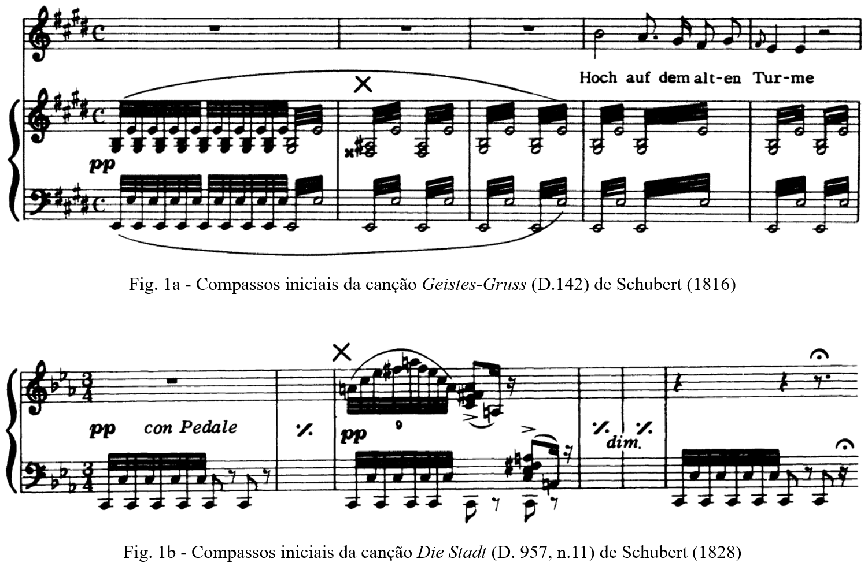

Figura 1 – Casos apresentados por Kerman (1962, p. 40-41) em
“A romantic detail in Schubert’s “Schwanengesang”

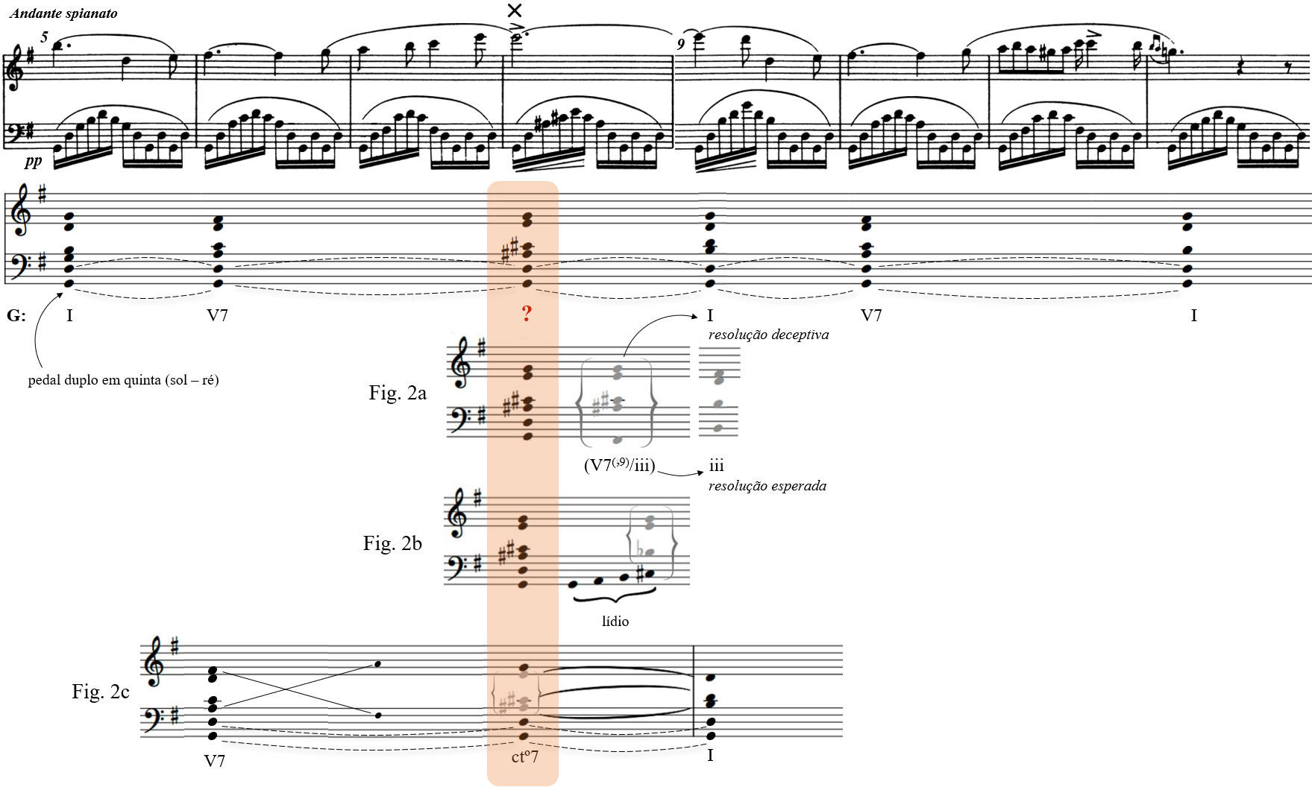

Figura 2 – Argumentos teóricos e analíticos na interpretação do acorde diminuto no compasso 8 do Op. 22 (c. 1830) de Chopin

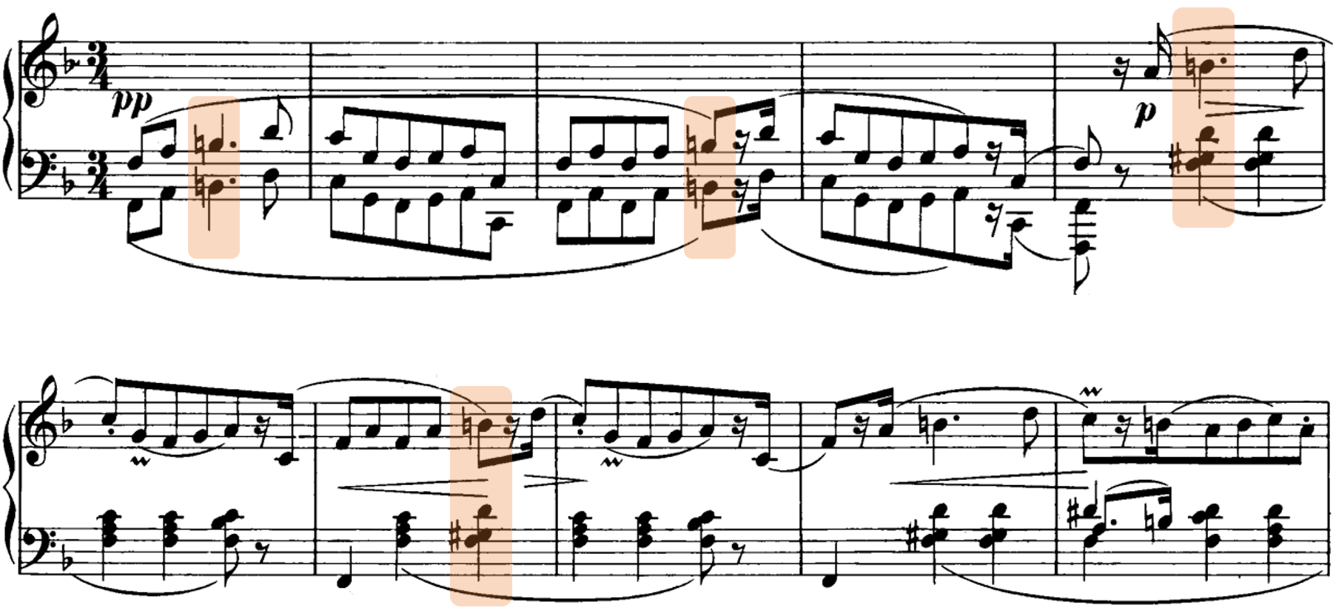

Figura 3 - Compassos iniciais do Rondeau à la Mazur, Op. 5 (1825), de Chopin

