Bomtempo Sonata Op. 18 n.1 - structural analysis of the 1st movement and some remarks on its themes

Figure 1 – Sonata Op. 18 n.1, 1st theme (mm. 1-17).
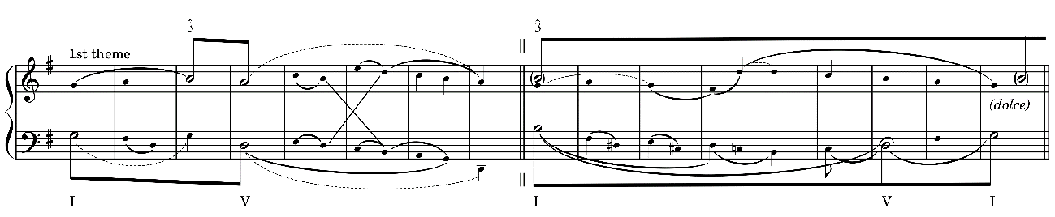

Fig. 2 – 1st theme, structural analysis of mm. 1-17
Fig. 3 – Bridge (mm. 17-24)
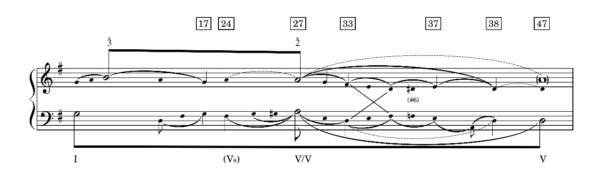
Figure 4 – Exposition (mm. 1-47)
Figure 5 – Tonicization of A in the beginning of the development section (mm. 49-50)
Figure 6 – New theme in the first section of the Development (mm. 51-62)
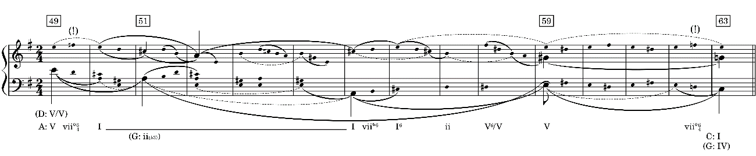
Figure 7 – Underlying structure of the new theme of the development section (mm. 49-63)
Figure 8 – 2nd section of the development and beginning of Recapitulation (mm. 63-82)
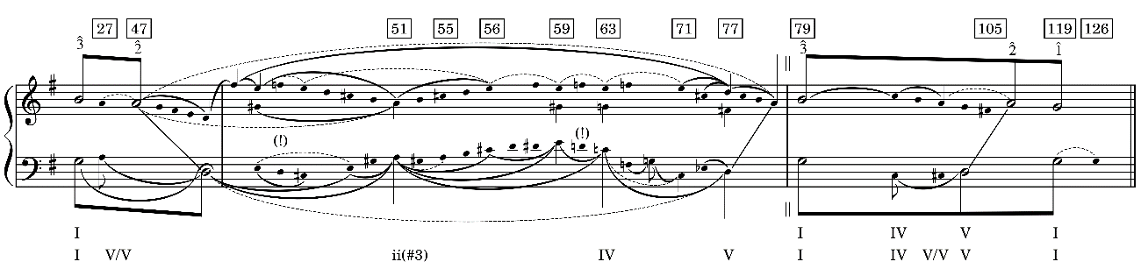
Figure 9 – Exposition, Development section and Recapitulation (mm. 1-126)
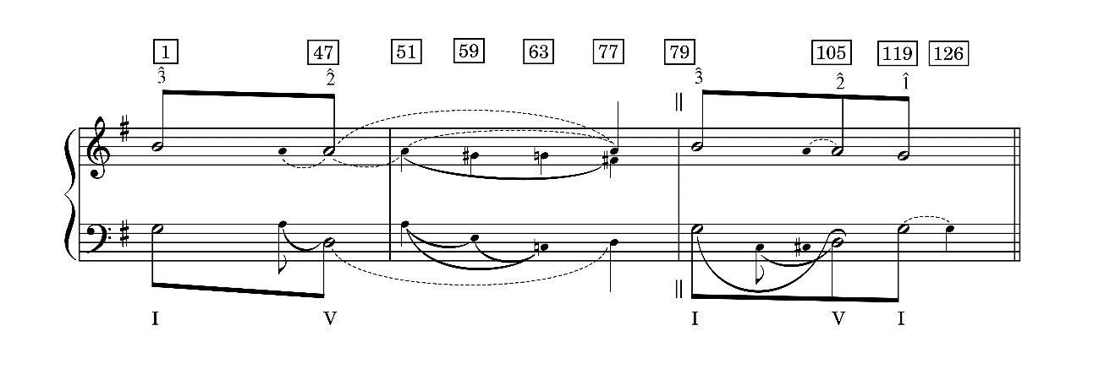
Figure 10 – Analytical sketch of the 1st movement of Bomtempo Sonata Op. 18 n.1

Bibliography
SANTOS, A. F. Domingos Bomtempo – nótulas sobre um eminente músico português. Porto: Fundação Eng. António de Almeida, 1992.
BACOVIS, A. C.. Elementos Formais, Texturais e Interpretativos nas Sonatas para piano de João Domingos Bomtempo (1775-1842). Dissertação. São Paulo: Unesp, 2017.
CONE, Edward T. ‘Musical Form and Musical Performance’ Reconsidered in Music Theory Spectrum , Spring, 1985, Vol. 7, Time and Rhythm in Music, pp. 149-158.
MAYER, Germano Gastal. A translation of João Domingos Bomtempo's piano method: a Portuguese contribution to piano pedagogy. D.M.A. Essay. University of Iowa, 2017.
___________________. João Domingos Bomtempo’s Piano Method: a Portuguese Contribution to Early Piano Pedagogy in Proceedings of Research Hands on PIANO - International Conference on Music Performance, Universidade de Aveiro, 2019.
SCHERPEREEL, Joseph. João Domingos Bomtempo – Musicien Portugais (XIXe Siècle). Fundação Calouste Gulbenkian, 1994.
SOUZA, Filipe de. Portugaliae Musica XXXV: João Domingos Bomtempo. Obras para piano. Edição fac-similada. Coligido por Filipe de Sousa. Lisboa: Fundação Calouste Gulbenkian, 1980.

