Algunas consideraciones formales y armónicas en la zamba argentina

Material suplementario
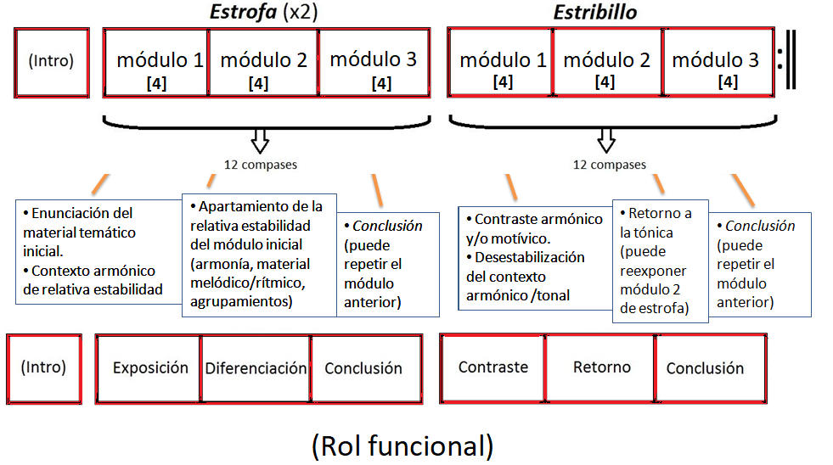
Roles funcionales en la organización formal de la zamba.
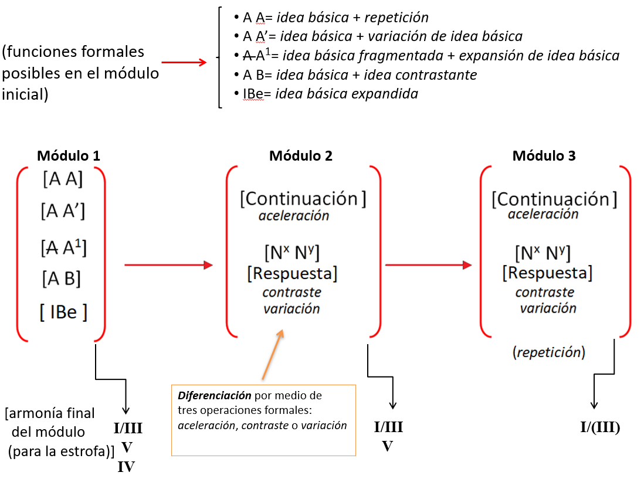
Relaciones formales entre módulos de la zamba
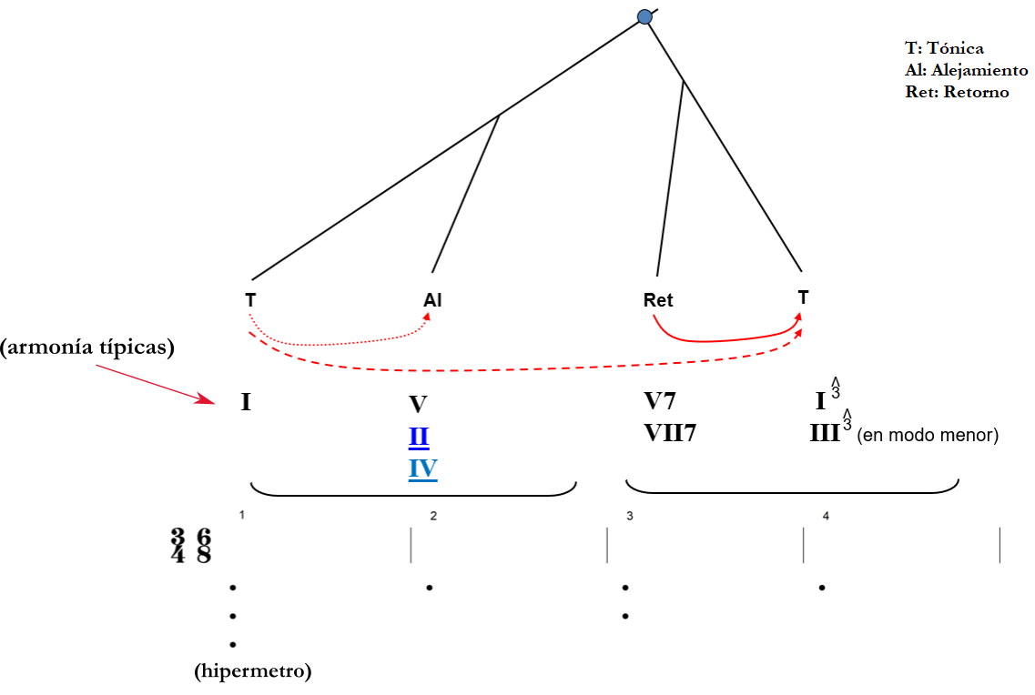
Forma básica del paradigma armónico alejamiento-retorno en el módulo inicial
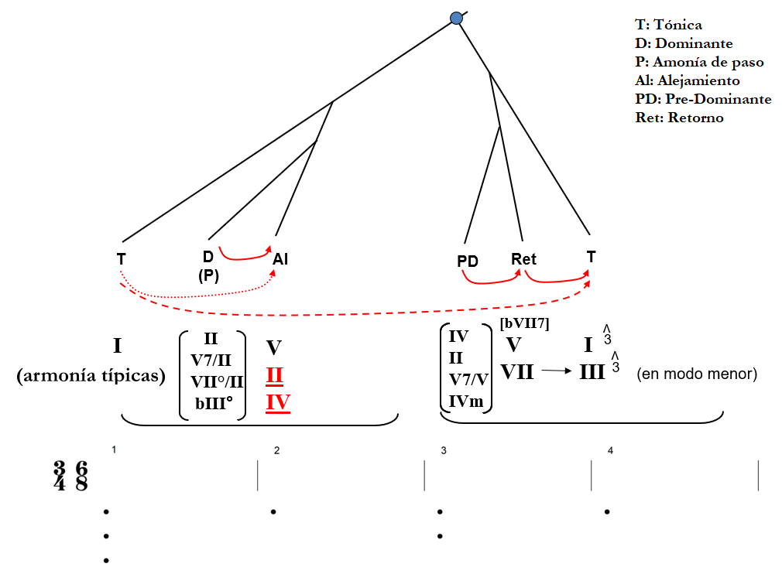
Algunas elaboraciones armónicas del paradigma alejamiento-retorno en el módulo inicial
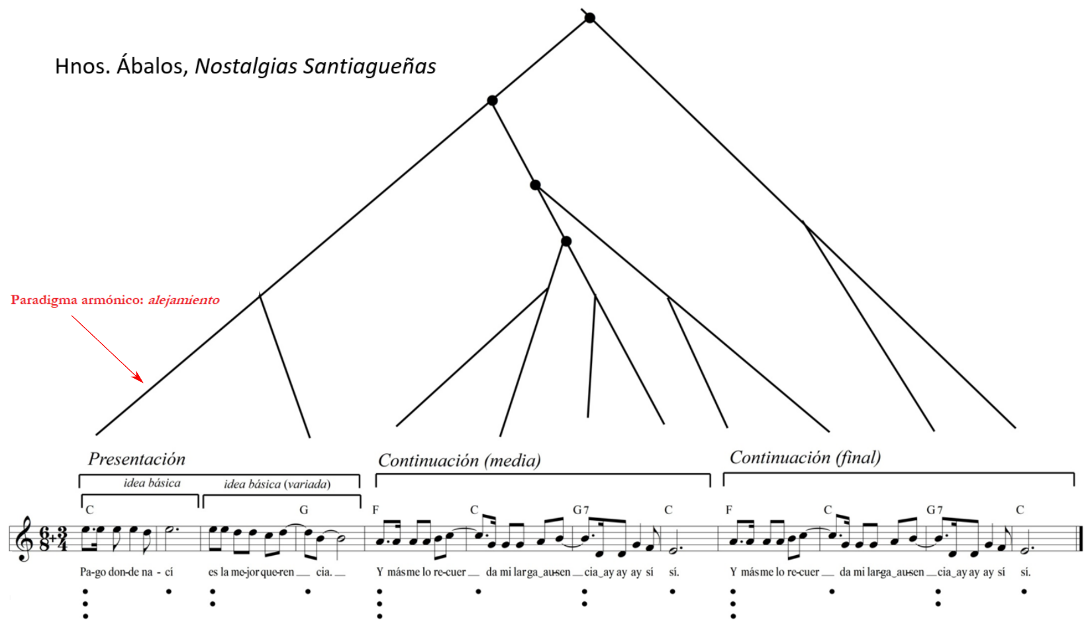
Análisis prolongacional de la estrofa inicial de Nostalgias Santiagueñas que comienza con el paradigma alejamiento en el módulo inicial.

Bibliografía:

Callahan, Michael (2013): Sentential Lyric-Types in the Great American Songbook, Music Theory Online (Vol.19, N.3). Disponible en Internet: http://www.mtosmt.org/issues/mto.13.19.3/mto.13.19.3.callahan.html

Caplin, William (1994): Hybrid Themes: Toward a Refinement in the Classification of Classical Theme Types. Beethoven Forum 3, Lincoln, University of Nebraska Press, pp. 151-65.

---------------------- (1998): Classical Form: a Theory of Formal Functions for the Instrumental Music of Haydn, Mozart, and Beethoven. New York, Oxford University Press.

Caplin, William, Hepokoski, James & Webster, James: Musical Form, Forms, Formenlehre. Three Methodological Reflections. Leuven, Leuven University Press.

Hepokoski James & Darcy, Warren (2006): Elements of Sonata Theory: Norms, Types, and Deformations in the Late Eigtheenth-Century Sonata. New York, Oxford University Press.

Navia, Gabriel & Ferrao Moreira, Gabriel (2019): Período, sentença ou híbridos? Aplicações da teoria das funções formais no estudo da forma do choro. Musica Theorica, Revista da Associação Brasileira de Teoria e Análise Musical 2019, V. 4, n. 2, p. 159–181.
-------------------------------------------- (2020): Incorporating Latin-American popular music in the study of musical form. En The Routledge Companion to Music Theory Pedagogy (ed. Leigh Van Handel). New York, Routledge.

Richards, Mark (2011): Viennese Classicism and the Sentential Idea: Broadening the Sentence Paradigm. Theory and Practice Vol. 36, pp. 179-224

Summach, Jason (2012): Form in Top-20 Rock Music, 1955-89. PhD diss., Yale University.

Vande Moortele, Steven (2011): Sentences, Sentence Chains, and Sentence Replication: Intra-and Interthematic Formal Functions in Liszt's Weimar Symphonic Poems, Intégral 25, pp. 121-158.

