Modelagem Gestáltica do Ponteio N. 30 de Camargo Guarnieri

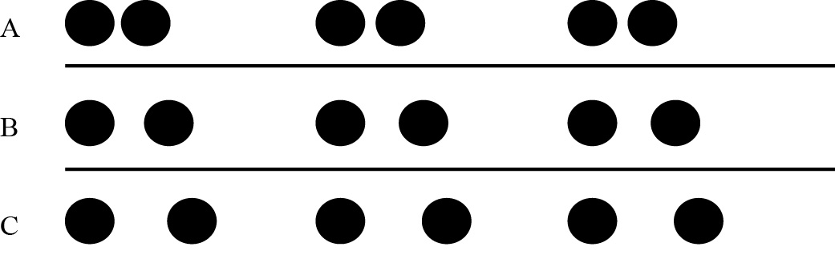
Figura 1. Exemplo visual do fator grupo objetivo

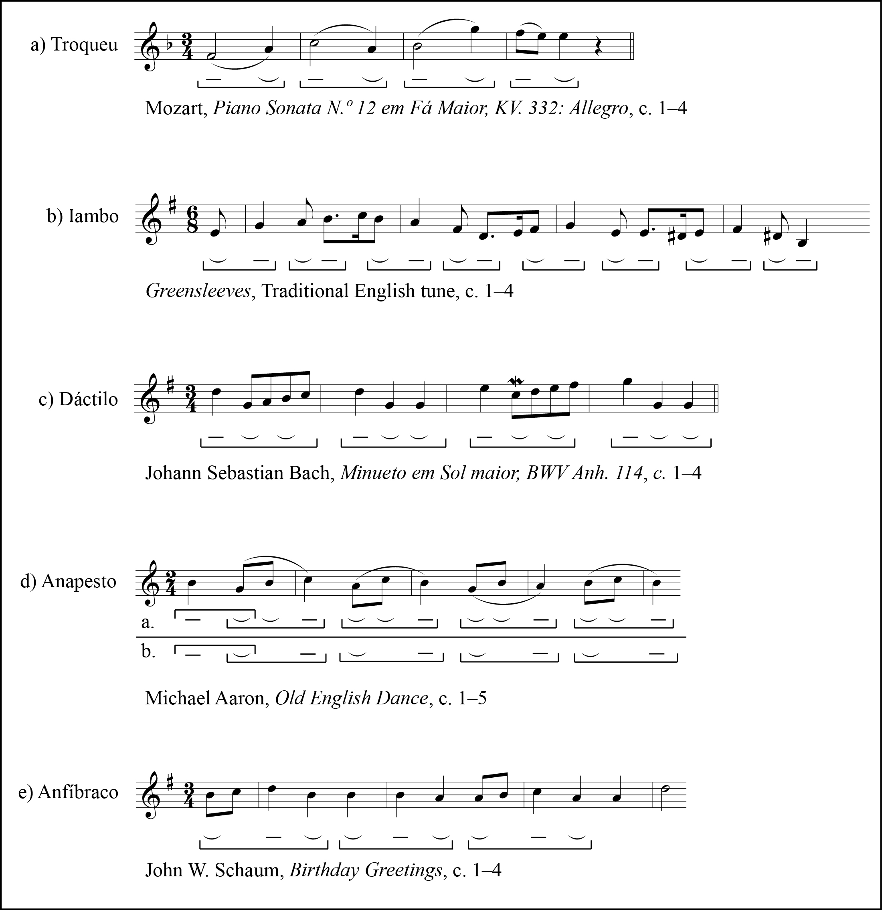
Figura 2. Tipos de agrupamento rítmico em repetição sucessiva

Referências

COOPER, Grosvenor; MEYER, Leonard B. The Rhythmic Structure of Music. 2. ed. Chicago & London: The University of Chicago Press, 1963.

KOFFKA, Kurt. Principles of Gestalt Psychology. London: Kegan Paul, Trench, Trubner & Co., Ltd.; New York: Harcourt, Brace & Co., 1936.

Xxxxxx

Yyyy

TENNEY, James. Meta+Hodos: A Phenomenology of 20th-Century Musical Materials and an Approach to Study of Form e META Meta+Hodos. Editor: Larry Polansky. 2. ed. Oakland: Frog Peak Music, 1988.

WERTHEIMER, Max. Laws of organization in perceptual forms. In: ELLIS, Willis D. (Ed.). A Source Book of Gestalt Psychologie. Highland: The Gestalt Journal Press, 1997. p. 71–88.

