Bored with minimalism:
John Adams’s first attempt at convoluting simplicity

Bored With Minimalism: John Adams’s First Attempt at Convoluting Simplicity
Thematic focus: Theory and analysis in tonal and post-tonal contexts
Abstract:

1. Introduction: John Adams’s special brand of minimalism
Composer John Adams has been described as a “minimalist bored with minimalism” (ADAMS, 2016, para. 3), having been born a decade after Steve Reich and Phillip Glass. Yet he chose minimalism as a solution to what he saw as the idealogical dead-ends presented by both post-Schoenbergian systematization and John Cage’s compositional methods. Although not entirely satisfied with the “inherent simplicities” of minimalism, Adams was attracted by the “tonality, pulsation and large architectonic structures” it employs (idem., para. 2). He admits, however, that together with his choice to adopt the style came a desire to find ways to “convolute and enrich” the simplicity of it (idem., para. 3).
Adams designates his 1977 piece for solo piano, China Gates, together with its companion piece Phrygian Gates, as his opus one, though he wrote several works previous to these. The two pieces occupy the position of first opus because they are what he considers his “first coherent statements in a new language” (idem., para 1)—a language which has been referred to by some as post-minimalism (“John Adams,” Open NYS, para. 4). Adams explains that his aim within this “new language” is not for minimalist processes to reign supreme, but for minimalist elements to form building blocks for somewhat neo-romantic structures. Repetition, simplicity and symmetry intertwine with romantic elements such as climax and directionalism. Adams explains:
…rather than set up small engines of motivic materials and let them run free in a kind of random play of counterpoint, I used the fabric of continually repeating cells to forge large architectonic shapes, creating a web of activity that, even within the course of a single movement, was more detailed, more varied, and knew both light and dark, serenity and turbulence. (ADAMS, 2010, para. 3).

Although China Gates does not explore neo-romantic expressiveness to the same extent some of the composer’s later works do, it does demonstrate, as ‘opus one,’ the composer’s first attempts at amalgamation of the elements listed above. As will be demonstrated in the following analysis, symmetry plays a prominent part on various levels of the piece, and minimalist motives serve a larger architectonic structure leading to climax and resolution, creating what Adams called an “almost perfect palindrome” (“John Adams, China Gates,” 2019).

2. Almost perfect palindromes in Sections 1 and 3 of China Gates
The “almost” of Adams’s description of his piece alerts us to the fact that there will be asymmetries and at least a measure of unpredictable irregularity in China Gates, though the majority fits within a symmetrical pattern. Palindromes are woven throughout the music on multiple levels. On the large scale, the overall formal proportions act in palindrome. The word “gates” in China Gates refers to electronic gates, or “moments when the modes abruptly and without warning shift. There is ‘mode’ in this music,” Adams explains, “but there is no ‘modulation’” (ADAMS, 2016, para. 3). The following figure shows an image provided by the composer at the beginning of the score to serve as a rough visual mapping of the gating in China Gates.
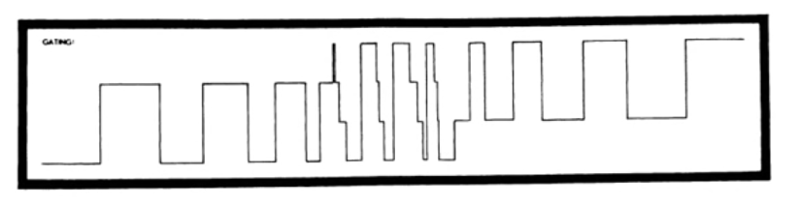
Figure 1: Adams’s image of gating in China Gates. (source: ADAMS, 1983)

As shown in the visual gating portrayal, the gates form three basic sections, the third section mirroring the first. The score reveals the first section to consist of eight gates, all beginning with a low A-flat/G-sharp in the bass followed by higher-register minimalist patterns in the right and left hands. The gates in Section 1 alternate between A flat mixolydian mode and G sharp minor mode, and the section as a whole lasts for a total of 300 quarter-note beats. The third section, nearly reflecting the first, consists of eight gates which begin this time with a low bass F, followed by the higher register minimalist patterns as in Section 1, but alternates now between F lydian and F locrian mode. This section likewise lasts for 300 quarter note beats. The middle section, being distinct from its surrounding two, dispenses with the low bass initial notes marking each gate change and contains only the higher-register minimalist patterns in right and left hands. It alternates systematically between all four modes (A mixolydian, G sharp minor, F locrian and F Lydian ) and contains 121 quarter note beats. Thus the durations of the sections function as a perfect palindrome (see Figure 2), and even the middle section with its 121 beats is itself a numeric palindrome.
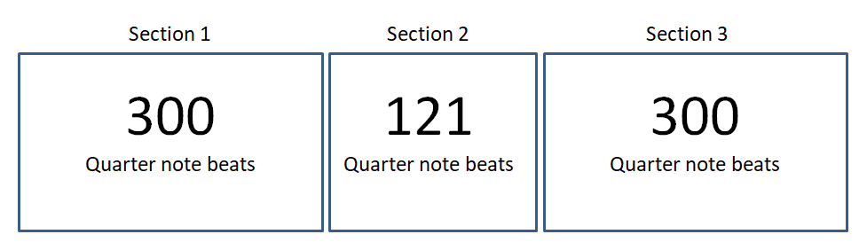
Figure 2: Palindromic proportions in the form of China Gates.

Dynamically the piece also creates a near palindrome shape, beginning Section 1 at piano, which grows un poco piu forte in the last third of the section. Section 2, as the center of the palindrome and climax section, stays at a consistent mezzo forte throughout. Section 3 begins its decline back to piano after the first third has passed, and spends its last third in pianissimo. Though not absolutely symmetrical, the dynamic scheme gives the piece a nearly perfect arc form and central climax, beginning and ending at a whisper.
Palindromes are at work as well inside Sections 1 and 3 which almost perfectly typify each other, except for the fact that a different pair of modes is explored in each section, and the minimalist upper-register patterns in each section do not strictly relate to those of the companion section. The eight gates which comprise respectively Sections 1 and 3 are grouped in proportional palindromic pairs. The duration of each pair of gates in Section 1 is related in multiples of 15, beginning larger and growing smaller, as shown in the Figure 3:

Gate number | Gate duration (in quarter notes)
1 | 60
2 | 60
3 | 45
4 | 45
5 | 30
6 | 30
7 | 15
8 | 15
Figure 3: Gate size in Section 1.

Likewise, Section 3 contains eight gates which palindromically mirror the size and proportions of the gates in Section 1, beginning smaller and growing larger, once again in multiples of fifteen, as shown in Figure 4.

Gate number | Gate duration (in quarter notes)
26 | 15
27 | 15
28 | 30
29 | 30
30 | 45
31 | 45
32 | 60
33 | 60
Figure 4: Gate size in section 3.

In addition to these proportional palindromes, the left hand material in each pair of gates acts in intervallic palindrome, even though the pitches and modes do not. This is most easily examined by looking at Gates 7 and 8 (see Examples 1 and 2), since they are small enough to each fit on one line, but examination of the score will show the same processes at work in all paired gates of Sections 1 and 3.
As shown in Example 1, the left hand material begins Gate 7 with a low A flat and then plays four repeated quarter notes in a higher register, followed by an ascending minor third repeated three times. Thereafter the melody works down a fourth, up a fourth, down a minor third, and down a whole step.

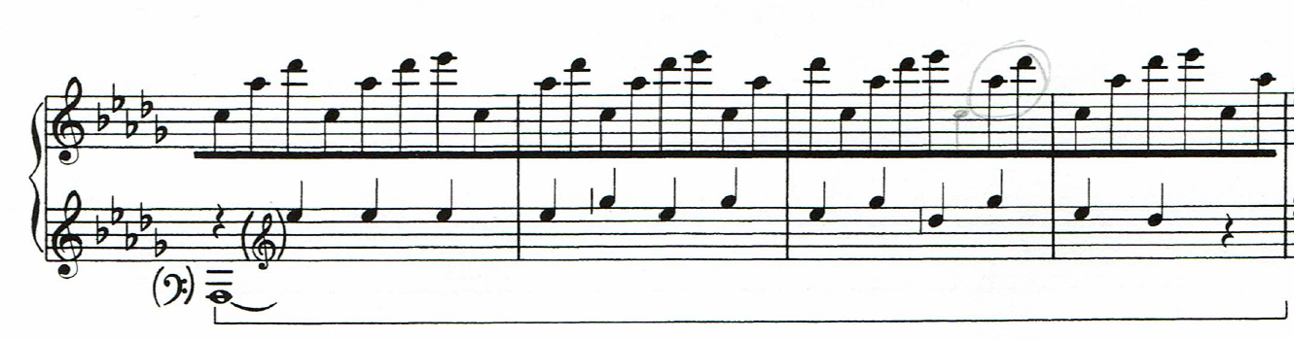
Example 1: Gate number 7.

The left hand in Gate 8, responding directly to Gate 7, plays not the same pitches but the same intervals in retrograde inversion. The left hand begins with a low G sharp once again as in gate 7 (A flat enharmonic), then jumps to treble clef, and begins to work its way backwards through the material from section 7, inverting the intervals in succession. To read the left hand intervals backwards in Gate 7 literally, one begins by ascending a whole step, then ascending a minor third, then descending a fourth, then ascending a fourth, and so on. Gate 8 inverts these backwards intervals, beginning by descending a whole step, descending a minor third, ascending a fourth, descending a fourth and so on, to end with the four repeated quarter notes with which Gate 7 began.

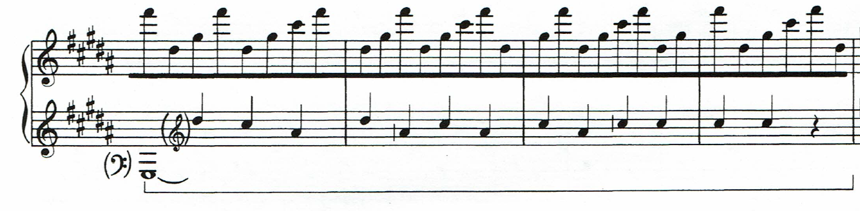
Example 2: Gate number 8.

The retrograde inversion interval relationship between the gates is easier to see when the left hand lines are placed side by side, as in the following example.

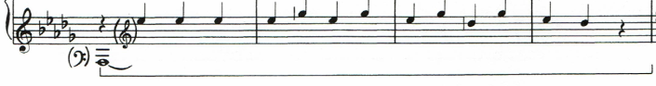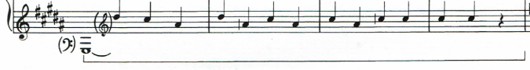
Example 3: Left hand lines in Gates 7 and 8, illustrating intervallic retrograde inversion.

In addition to intervallic retrograde, there is also a rhythmic retrograde at work in all the paired gates from Sections 1 and 3. Gates 7 and 8 just shown are composed only of quarter notes, so the rhythmic retrograde is not as remarkable here, but in examining Gates 5 and 6 the rhythmic relationship becomes pronounced. Gate 5’s treble-clef left-hand patterns begin with an eighth note followed by what amounts to a quarter note, repeated three times, followed by an eighth tied to a quarter, then five quarter notes, and then a succession of thirty-four eighth notes (See Example 4).
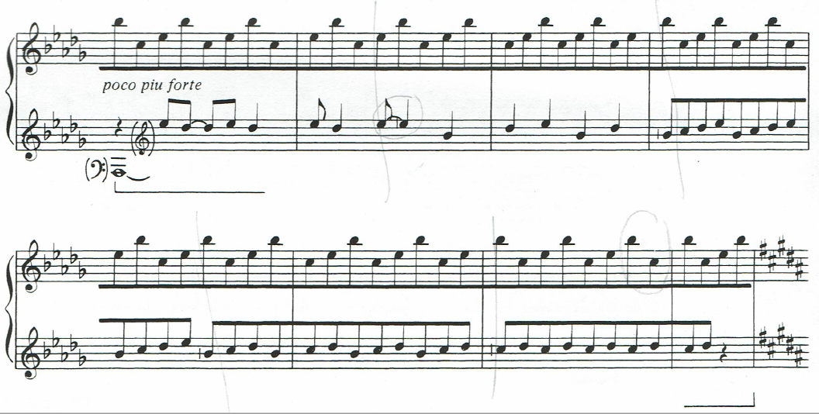

Example 4: Gate 5.

Gate 6 plays these rhythms in strict retrograde, as if the pianist were simply reading the rhythms backwards. The left hand begins with the thirty-four eights notes that ended Gate 5, followed by five quarters, then a quarter note tied to an eighth (note that in Gate 5 we had instead an eighth note tied to a quarter; here in Gate 6 the order is reversed), then a thrice repeated sequence of a quarter note followed by an eighth note (where in Gate 5 we had three times an eighth note followed by a quarter).
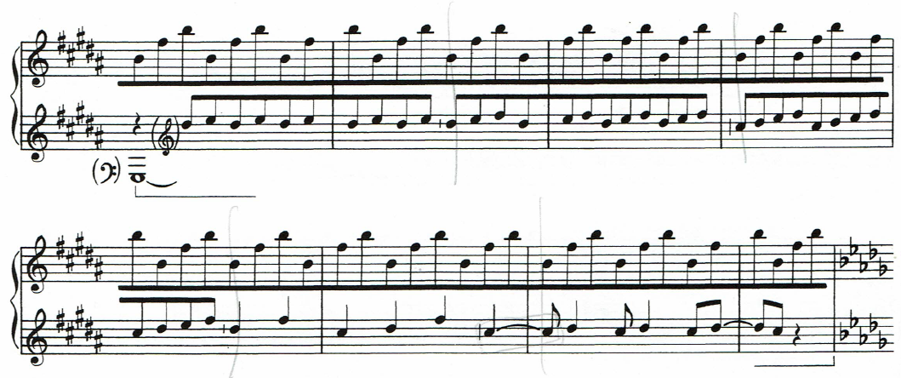
Example 5: Gate 6.

In addition to the rhythmic retrograde, please note the presence also of left-hand intervallic retrograde inversion in Gates 5 and 6, just as was previously demonstrated in Gates 7 and 8. These processes remain true throughout sections 1 and 3. The predictability and symmetry is not complete, as mentioned previously, since the right hand motives, differing from the left, do not have any direct recognizable pairing between gates or, on a larger scale, between the sections, but palindromes are nevertheless woven into the proportions, dynamics, rhythms and intervals of the outside sections .

3. Almost perfect palindromes Section 2
There are prominent palindromes at work in Section 2 as well, though they do not pass being “almost perfect.” Section 2 cycles exactly four times through all four modes used in Sections 1 and 3 in the following systematic order: F lydian, G sharp minor, F locrian, and A flat mixolydian. Time spent in each individual mode varies, but the total sum time of each of the four-mode cycles is a consistent thirty quarter note beats. The “almost” perfection in Section 2 shows up in the third mode cycle which lasts not thirty, but thirty-one quarter note beats. This cycle has an extra “almost” central gate, Gate 21, of one single quarter note: the only gate in the entire piece of this tiny size (it is “almost” central because it is not quite in the middle of the work’s 33 gates). As such, it acts perhaps as the fulcrum upon which the piece pivots, giving the central section 121 beats and its numeric palindrome. The four cycles through the modes in this section all contain four gates respectively, except this third cycle which contains five due to Gate 21, the extra one-beat gate. Whereas in all the other cycles the mode changes clearly coincide with each gate change, in this third cycle there is a bit of blurring between the mode changes around the “fulcrum” gate 121, so as to fit the four modes into five gates instead of four. The third cycle begins predictably in F Lydian mode in Gate 17, changes to G sharp minor in Gate 18, F locrian in Gate 19, but Gate 20 is ambiguous and does not clearly shift away from F locrian into A flat mixolydian; it could be either one. Gate 21 steps more firmly into A flat mixolydian because of a prominent A flat appearing in the right hand (see Example 6). The importance of this blurring or overlap between modes in Gates 19- 21will be returned to in a moment, to show its contribution to the fulcrum function of Gate 21.

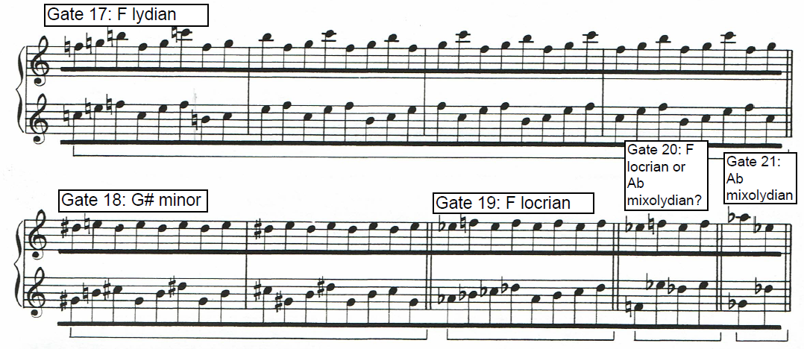Example 6: Gate changes and mode changes in cycle three, Section 2.

There are interesting durational symmetries within the individual cycles that are found by counting the number of quarter note beats spent in each mode. Cycle one spends two beats in F lydian, four beats in G sharp minor, eight beats in F locrian, and sixteen beats in A flat mixolydian. Cycle three inverts this sequence by spending sixteen beats in F lydian, eight beats in G sharp minor, four beats in F locrian, and two beats in the ambiguous mode (F locrian or A flat mixolydian). The extra gate in cycle three stands outside this symmetry, adding an additional beat onto the end of this numeric sequence.
Similarly, cycle two follows a numeric sequence which is inverted in cycle four. Cycle two begins with 15 beats in F lydian, two beats in G sharp minor, four beats in F locrian, and 9 beats in A flat mixolydian. Cycle four “almost” perfectly inverts this sequence by starting with eight beats in F lydian, then four beats in G sharp minor, two beats in F locrian, and fifteen beats in A flat major. The asymmetry of the eight beats which start cycle four could be rounded out to the symmetrical nine beats of its mirror cycle (Cycle 2) if we adopt the “extra” one-beat of Gate 21 which immediately precedes it, into the sum. This symmetry is only “almost” perfect, however, because the modes do not agree between the Gate 21 (A flat mixolydian) and Gate 22 (F lydian).
Interestingly, the extra one-beat, the fulcrum Gate 21, thus acts as a bridge between what comes before and what comes after. It bridges with what comes before it by having a possible modal overlap with Gate 20, where we had an ambiguous mode (F locrian or A flat mixolydian), which then overlaps with the A flat mixolydian of Gate 21 (see Example 6). It bridges with what comes after it by completing the numeric symmetry (8+1) needed for cycle four to mirror cycle two. The durational symmetries and the numeric bridge function of the extra one-beat measure, connecting cycle three to cycle four, are outlined in Figure 5 below.

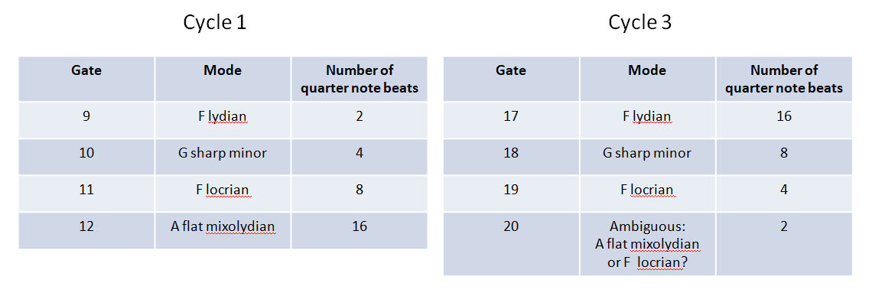
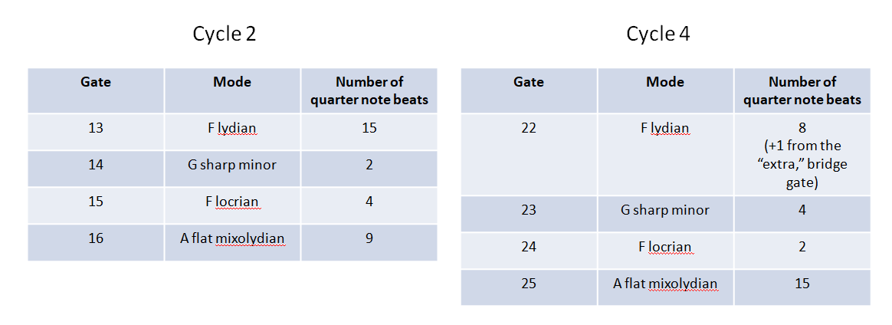
Figure 5: Palindromic duration of modes in Cycles 1-4, Section 2.

The bridging function of Gate 21 gives it the character of the key stone in the arch of the nearly palindromic form of China Gates. Though this gate, when heard away from the score, does not call attention to itself as the single climactic moment of the piece, it does reside within the clearly climactic middle section. It is evident from dynamic, modal and mathematical analysis, such as that done here, that formal planning of palindromic structures is an essential organizing element behind Adams’s compositional technique in China Gates.

4. Conclusion
Adams’s special brand of minimalism, expressed for the first time here in his self-designated opus one, does employ minimalist processes, like the palindromic pairing in Sections 1 and 3 which lasts for increasing or decreasing multiples of 15 quarter notes, yet he finds ways to “convolute and enrich” these simple processes with a grain of unpredictability and variability. His methods for doing this include the following: the right hand acts free and untethered to the left hand rhythmic and intervallic palindromes at work in Sections 1 and 3; the left-hand pitches in the paired palindromic sections differ, though the intervals are mirrored; the modes and minimalist motives utilized in Section 1 are different from those used in the parallel section, Section 3, even though the palindromic pairing processes of other aspects are visible in both sections; slight asymmetries exist in the arc form, such as the dynamic scheme not being a perfect, but a slightly lop-sided arc, the placement of the “keystone” gate being not exactly in the mathematical center of the form, and so on. In addition to adding these elements of variability, Adams adds a dash of neo-romanticism by couching the simplicity and semi-symmetry of the music within a form which expresses development and resolution through its arc, its energy accumulation and dissipation. Adams’s goal to employ minimalistic language yet explore more detail, variety, serenity and turbulence is thus first here attempted. It is clear that symmetry is an important organizing principle, yet the “almost” in the almost perfect palindrome of China Gates adds some detail and variation, and the composer’s implementation of directional development to a climax and resolution pays homage to his desire for exploring serenity and turbulence. It is a simple tour of rise and fall, using symmetries and minimalist (and a sprinkling of non-minimalist) vocabulary to construct a “gated” journey uphill and down again, exploring on the way, as Adams reflects, “details of dark, light and the shadows that exist between” (ADAMS, 2016, para. 5).

Keywords: John Adams, China Gates, post-minimalism, palindromes.

Bibliography:

ADAMS, John. China Gates. New York, NY: Associated Music Publishers, Inc., 1983. Partitura.

ADAMS, John. China Gates and Phrygian Gates. John Adams. 2016. Retrieved from https://www.earbox.com/phrygian-gates-china-gates/ Accessed Nov. 29, 2019.

ADAMS, John. Harmonium. John Adams. 2010. Retrieved from https://web.archive.org/web/20130117202009/http://www.earbox.com/W-harmonium.html
Accessed Nov. 29, 2019.

John Adams. Open NYS. Lumen Learning. Retrieved from https://courses.lumenlearning.com/suny-musicapp-medieval-modern/chapter/john-adams/ Accessed Nov. 29, 2019.

John Adams, China Gates. Music Sales Classical. Music Sales Group, 2019. Retrieved from http://www.musicsalesclassical.com/composer/work/23701. Accessed Nov. 29, 2019.

In the absence of a time signature, rather than counting measures which are sometimes irregular in length, it is more pertinent to count quarter notes as the basic measurement unit of the piece.

